arrayList

Why aRrayList instead of array
  - Is a part of the Java library, like the String and Math classes.
  - It can be used to store a list of objects.
  - Has a set of useful methods for managing its elements:
    - add(), get(), remove(), indexOf(),

How is it Different from an Array

It can only hold objects
- An ArrayList can contain only objects, not primitives.
  - It may contain any object type, including a type that you created by writing a class.
- For example, an ArrayList can hold objects of type:
  - String
  - Person
  - Car

Java handles a lot of the work
- Dynamic resizing:
  - An ArrayList grows as you add elements.
  - An ArrayList shrinks as you remove elements.
- Several built-in methods:
  - An ArrayList has several methods to perform operations.
  - For example, to add, retrieve, or remove an element

You access it using methods not an index
- You don’t access elements in an ArrayList by using index notation.
- Instead, you use a series of methods that are available in the ArrayList class.
add(value) | Appends the value to the end of the list
add(index, value) | Inserts the given value just before the given index, shifting subsequent values to the right
clear() | Removes all elements of the list
indexOf(value) | Returns the first index where the given value is found in the list (-1 if not found)
get(index) | Returns the value at the given index
remove(index) | Removes the value at the given index, shifting subsequent values to the left
set(index, value) | Replaces the value at the given index with a given value
size() | Returns the number of elements in the list
toString() | Returns a string representation of the list, such as "[3, 42, -7, 15]"

Example:
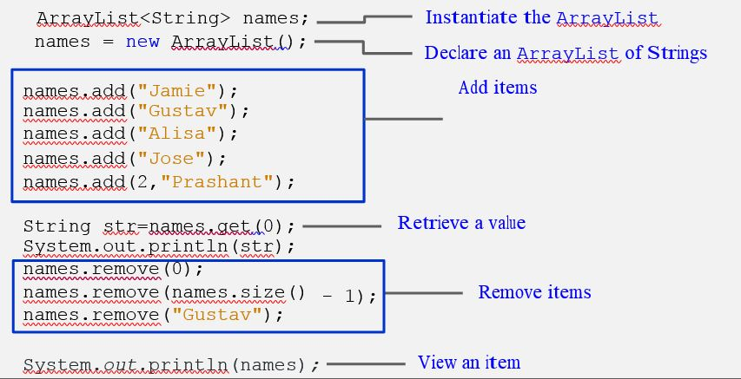

Limitations of an ArrayList – Can Only Store Objects

Use Wrapper Classes
- Java provides classes, known as wrapper classes, that correspond to the primitive types.
- These classes encapsulate, or wrap, the primitive types within an object.
- The eight wrapper class types correspond to each primitive data type.
Primitive Type | Wrapper Type
byte | Byte
Short | Short
int | Integer
long | Long
float | Float
double | Double
char | Character
boolean | Boolean

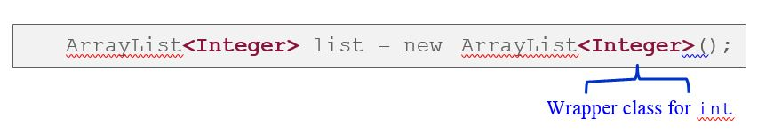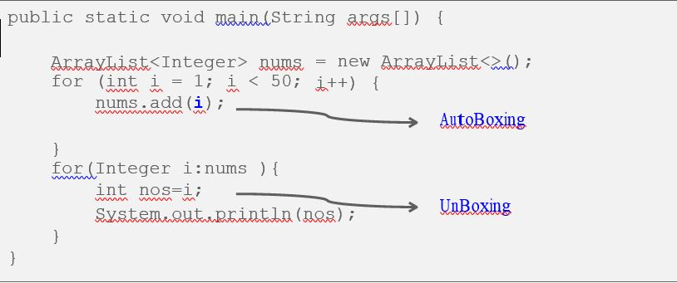

AutoBoxing – autoconversion between primitive and wrapper class
- The automatic conversion that the Java compiler makes between the primitive types and their corresponding object wrapper classes.
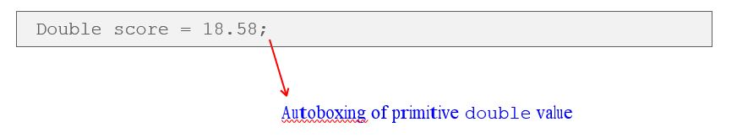

Unboxing
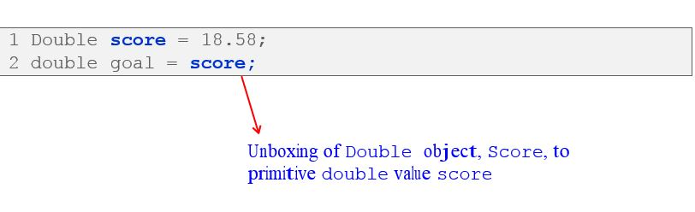

Traversing an ArrayList – For Each loop
- The variable i represents a particular name as you loop through the names ArrayList.
